Steps to Run program

1. Download code form GIT HUB : <https://github.com/nreddy0504/QA-Automation>

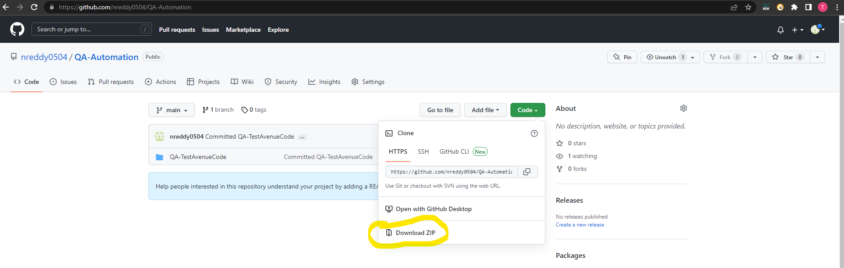

1. Open a workspace in Eclipse IDE and import project

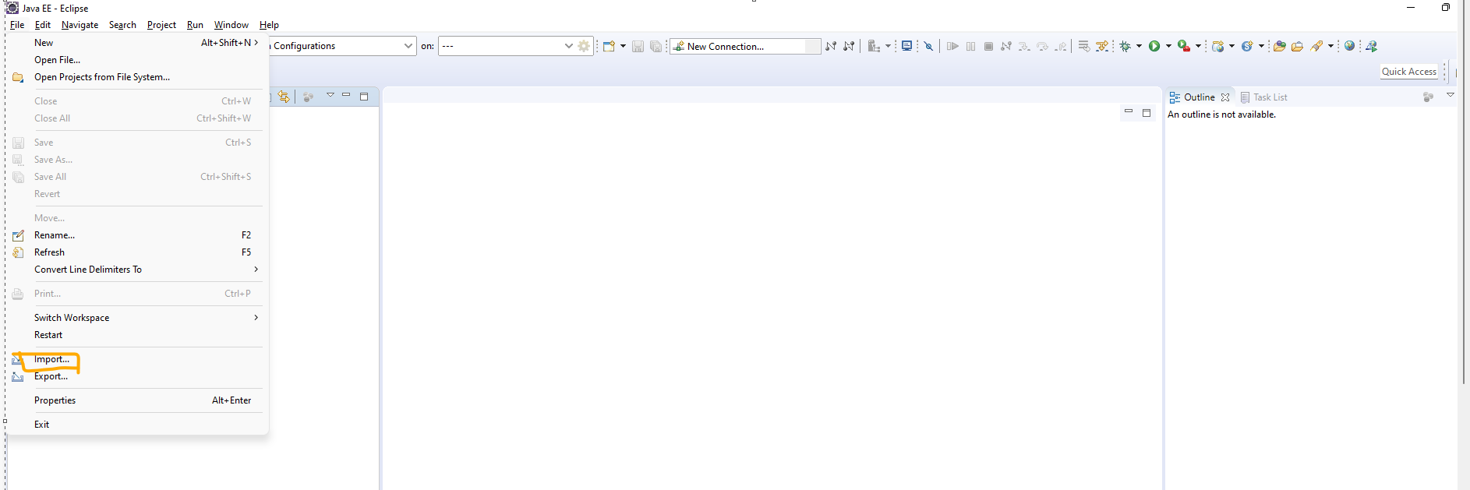

1. Select maven project and press next

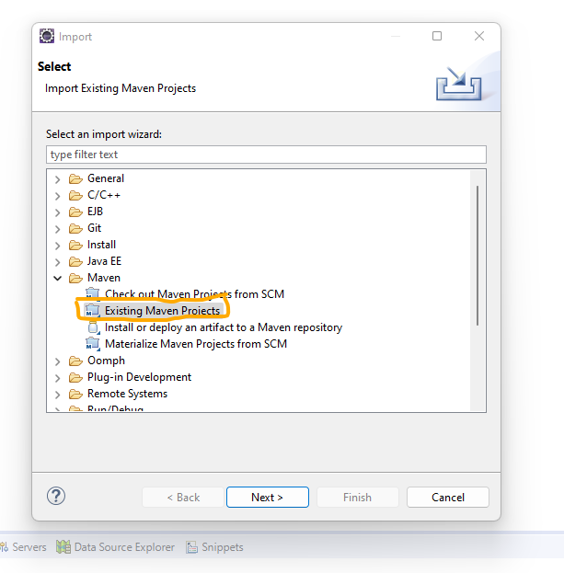

1. Browse to downloaded folder and press OK. Press Finish on next screen

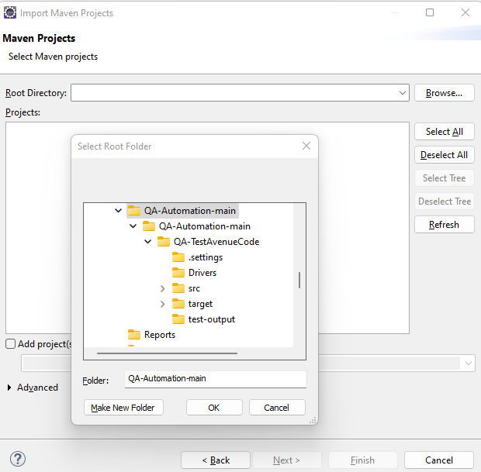

1. Go to the Project Explorer at left side window and go to the folder QA-TestAvenueCode/src/main/java/runner/ and right click on the TestRunner.java file and Run as JUnit Test

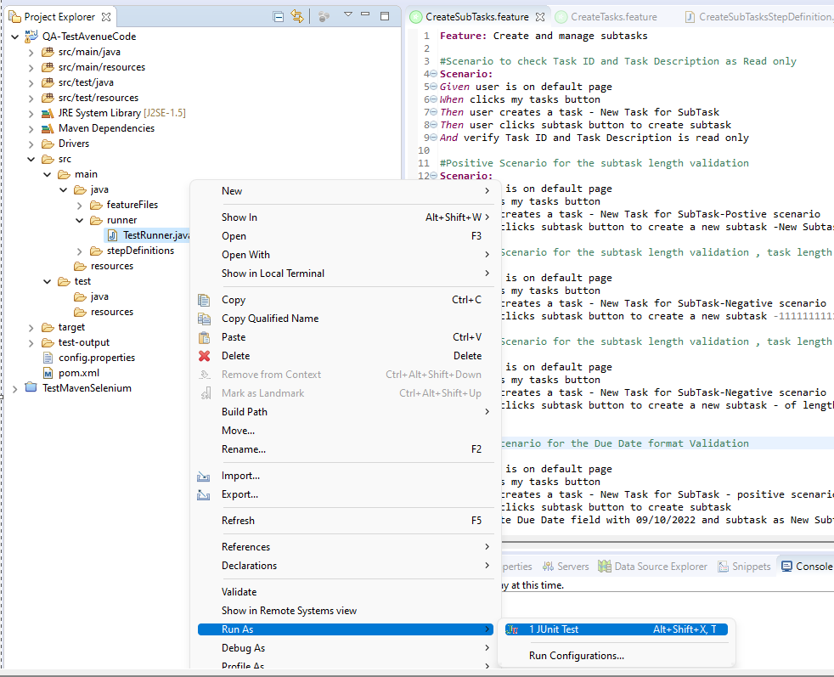

1. Program execution will start and will take around 5 min
2. Post execution,Test Report can be found at location QA-TestAvenueCode/test-output/index.html . Open it in a browser to view

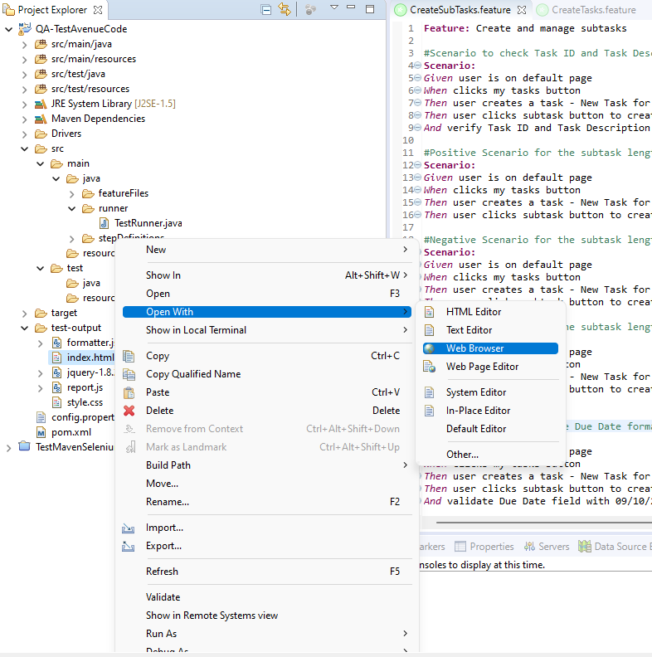

1. Test Report

